1. **itter Developer Account Keys:**

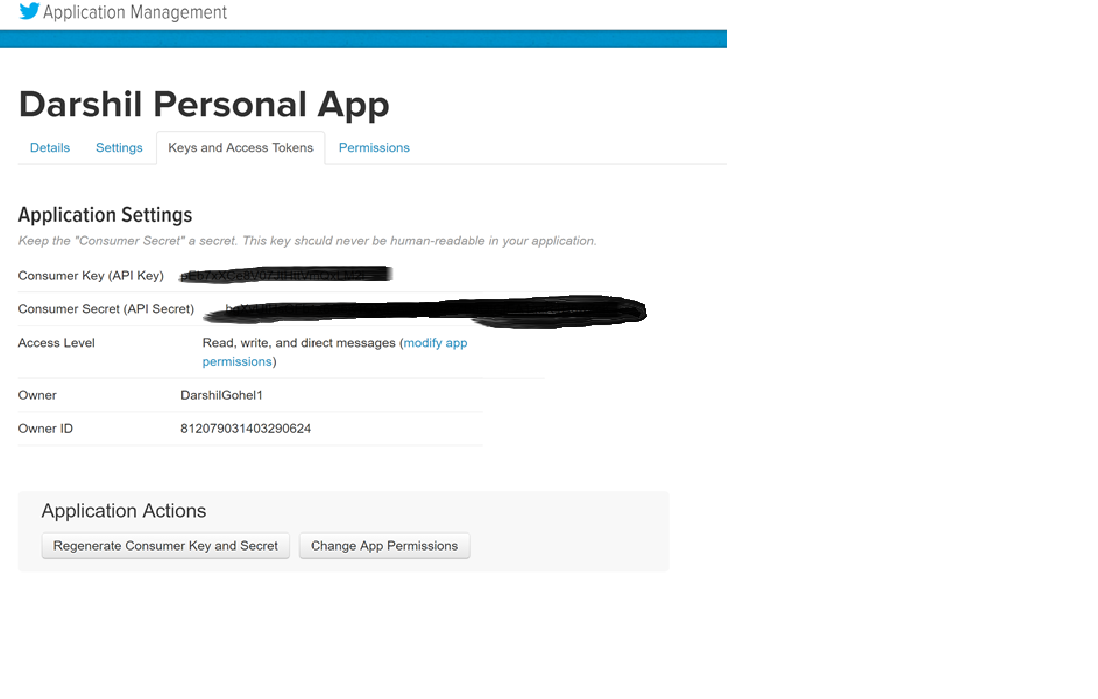

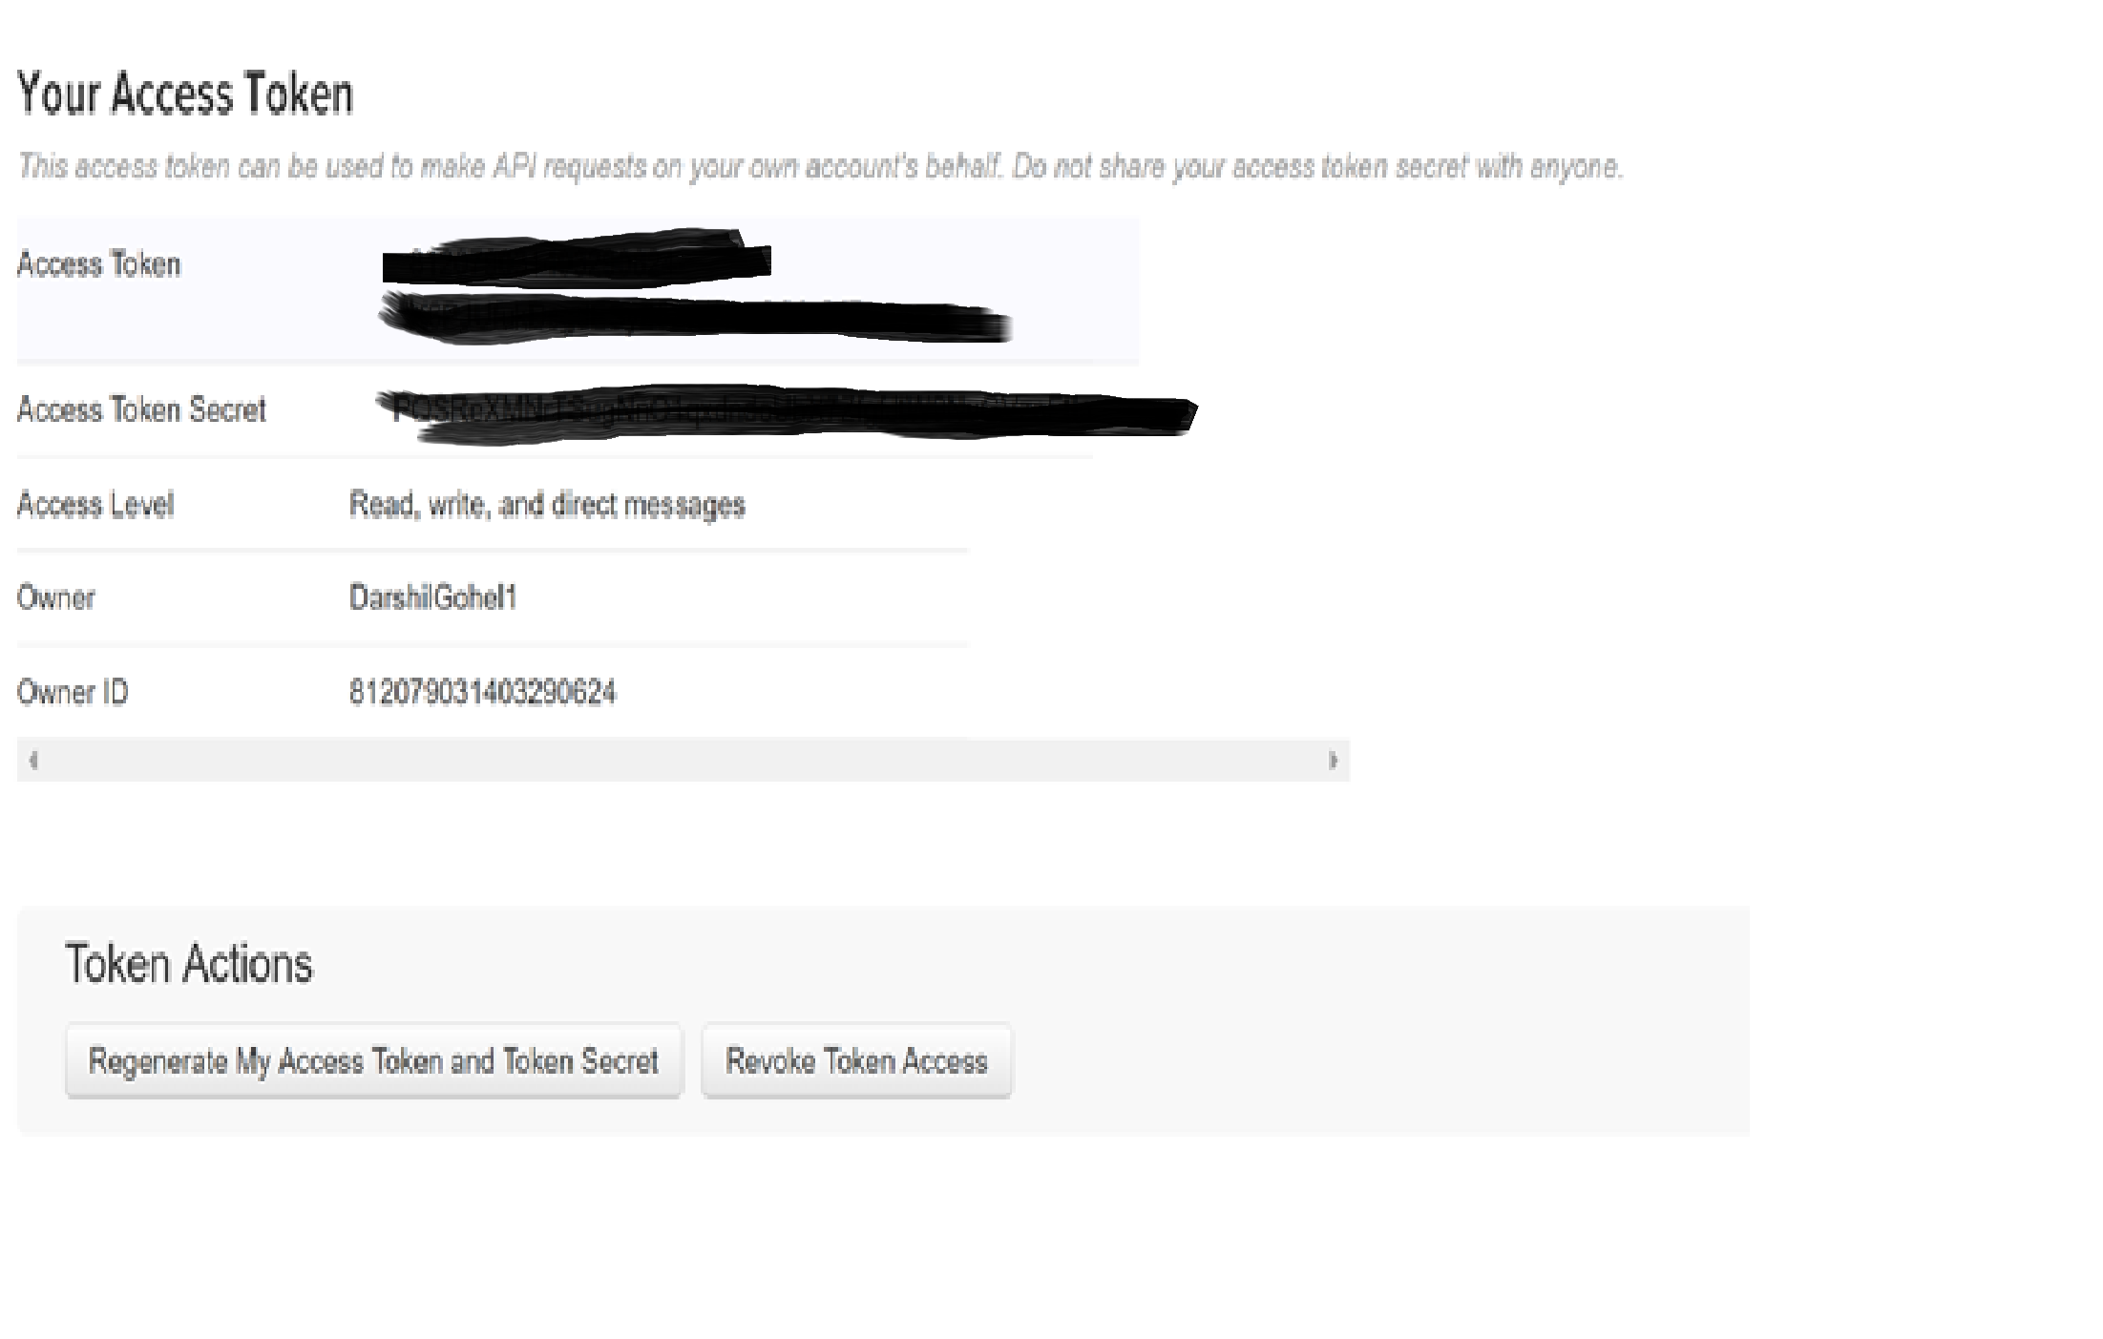

1. **HDFS Sink Configuration:**
2. **Ensure following jar file are present in path : (/usr/lib/flume-ng/lib)**

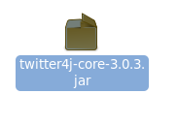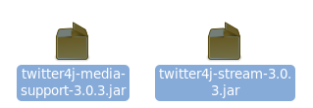



1. **Configured Flume agent:**



Give following values in .conf file ( flume-twitter.conf in /Desktop path)

# spooldir.conf: A Spooling Directory Source

# Name the components on this agent

TwitterAgent.sources = Twitter

TwitterAgent.channels = MemChannel

TwitterAgent.sinks = HDFS

# Describing/Configuring the source

TwitterAgent.sources.Twitter.type = org.apache.flume.source.twitter.TwitterSource

TwitterAgent.sources.Twitter.consumerKey=

TwitterAgent.sources.Twitter.consumerSecret=

TwitterAgent.sources.Twitter.accessToken=

TwitterAgent.sources.Twitter.accessTokenSecret= TwitterAgent.sources.Twitter.keywords=hadoop, bigdata, mapreduce, mahout, hbase, nosql, election,sports, cricket

TwitterAgent.sources.Twitter.channels=MemChannel

# Describing/Configuring the sink

TwitterAgent.sinks.HDFS.channel=MemChannel

TwitterAgent.sinks.HDFS.type=hdfs

TwitterAgent.sinks.HDFS.hdfs.path=/loudacre/twitter

TwitterAgent.sinks.HDFS.hdfs.fileType=DataStream

TwitterAgent.sinks.HDFS.hdfs.writeformat=Text

TwitterAgent.sinks.HDFS.hdfs.batchSize=100

TwitterAgent.sinks.HDFS.hdfs.rollSize=0

TwitterAgent.sinks.HDFS.hdfs.rollCount=100

TwitterAgent.sinks.HDFS.hdfs.rollInterval=100

TwitterAgent.sinks.HDFS.hdfs.useLocalTimeStamp=true

TwitterAgent.channels.MemChannel.type=memory

TwitterAgent.channels.MemChannel.capacity=1000

TwitterAgent.channels.MemChannel.transactionCapacity=1000

1. **Make sure HDFS directories are present :**

sudo -u hdfs hadoop fs -mkdir /loudacre/twitter

1. **Running the Flume Agent:**

flume-ng agent --conf /etc/flume-ng/conf \

--conf-file Desktop/flume-twitter.conf \

--name TwitterAgent -Dflume.root.logger=INFO,console

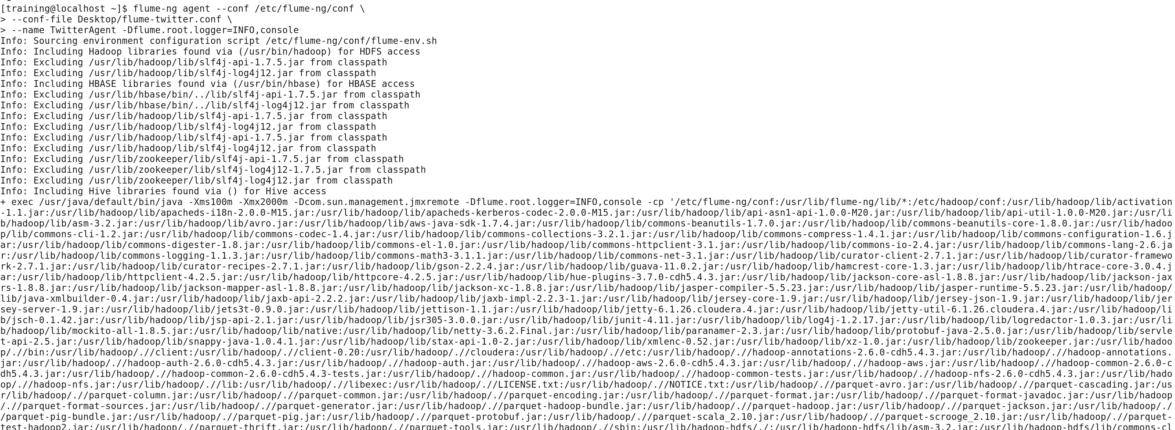

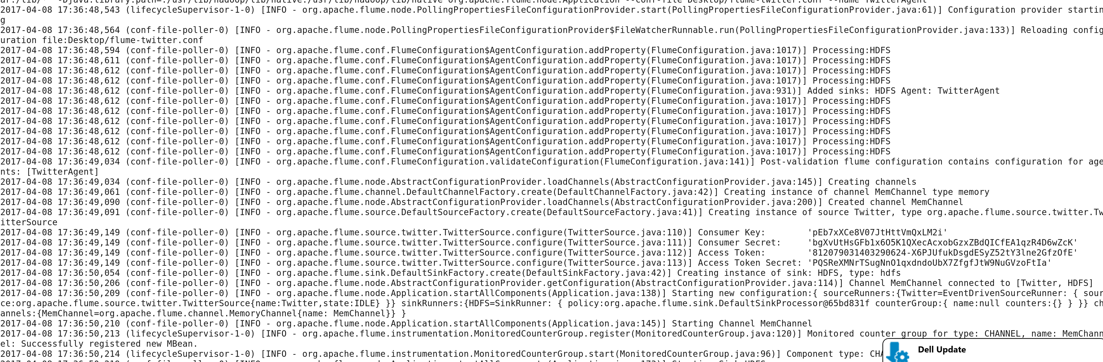

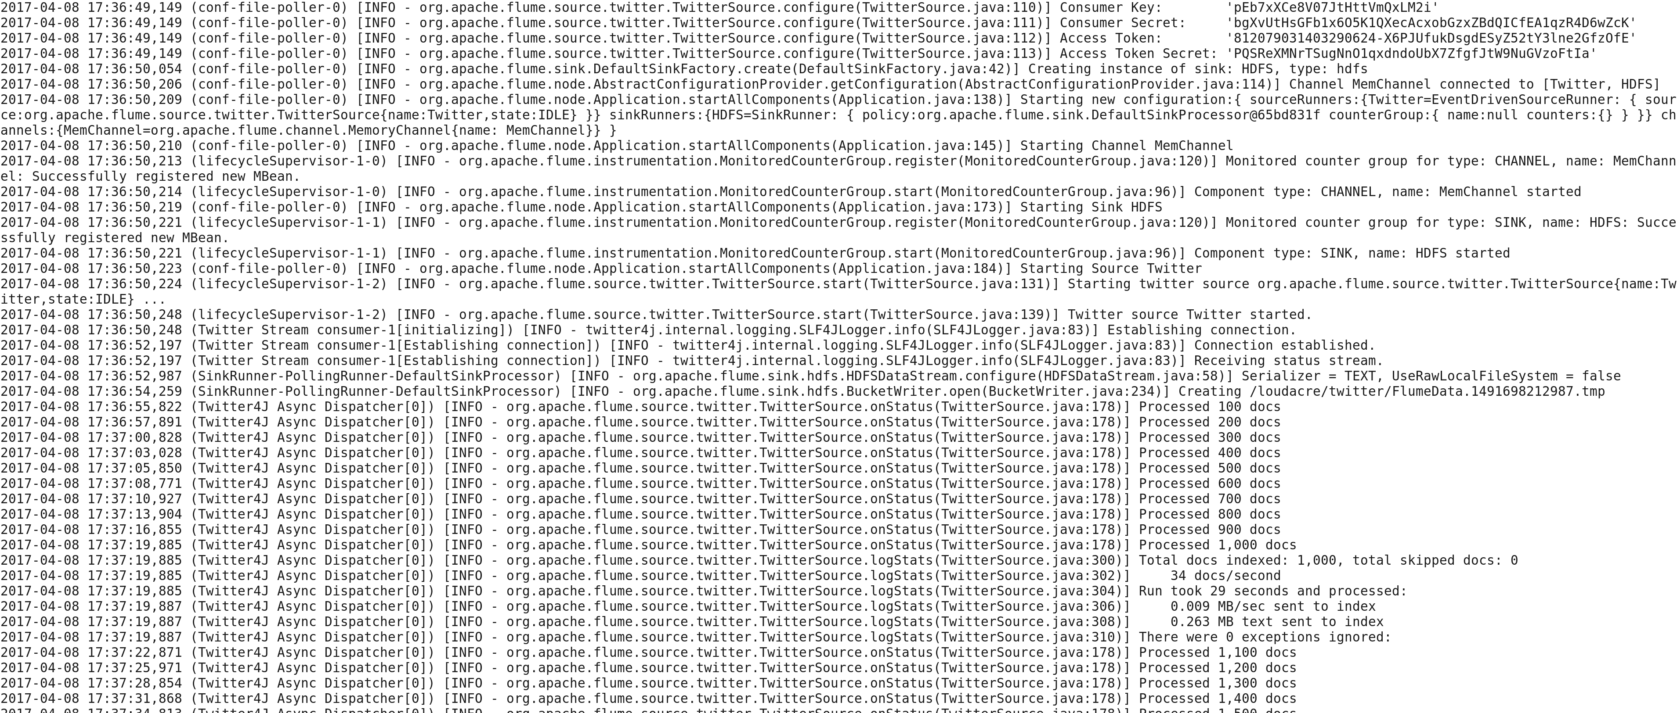

1. **Output Directories :**

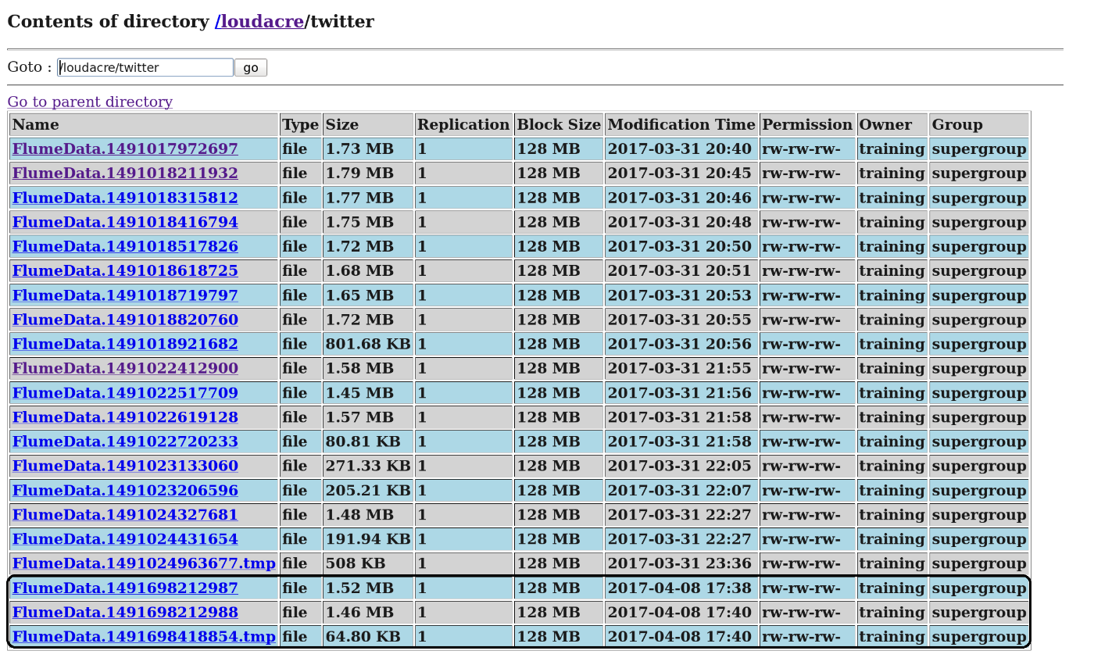

Data:

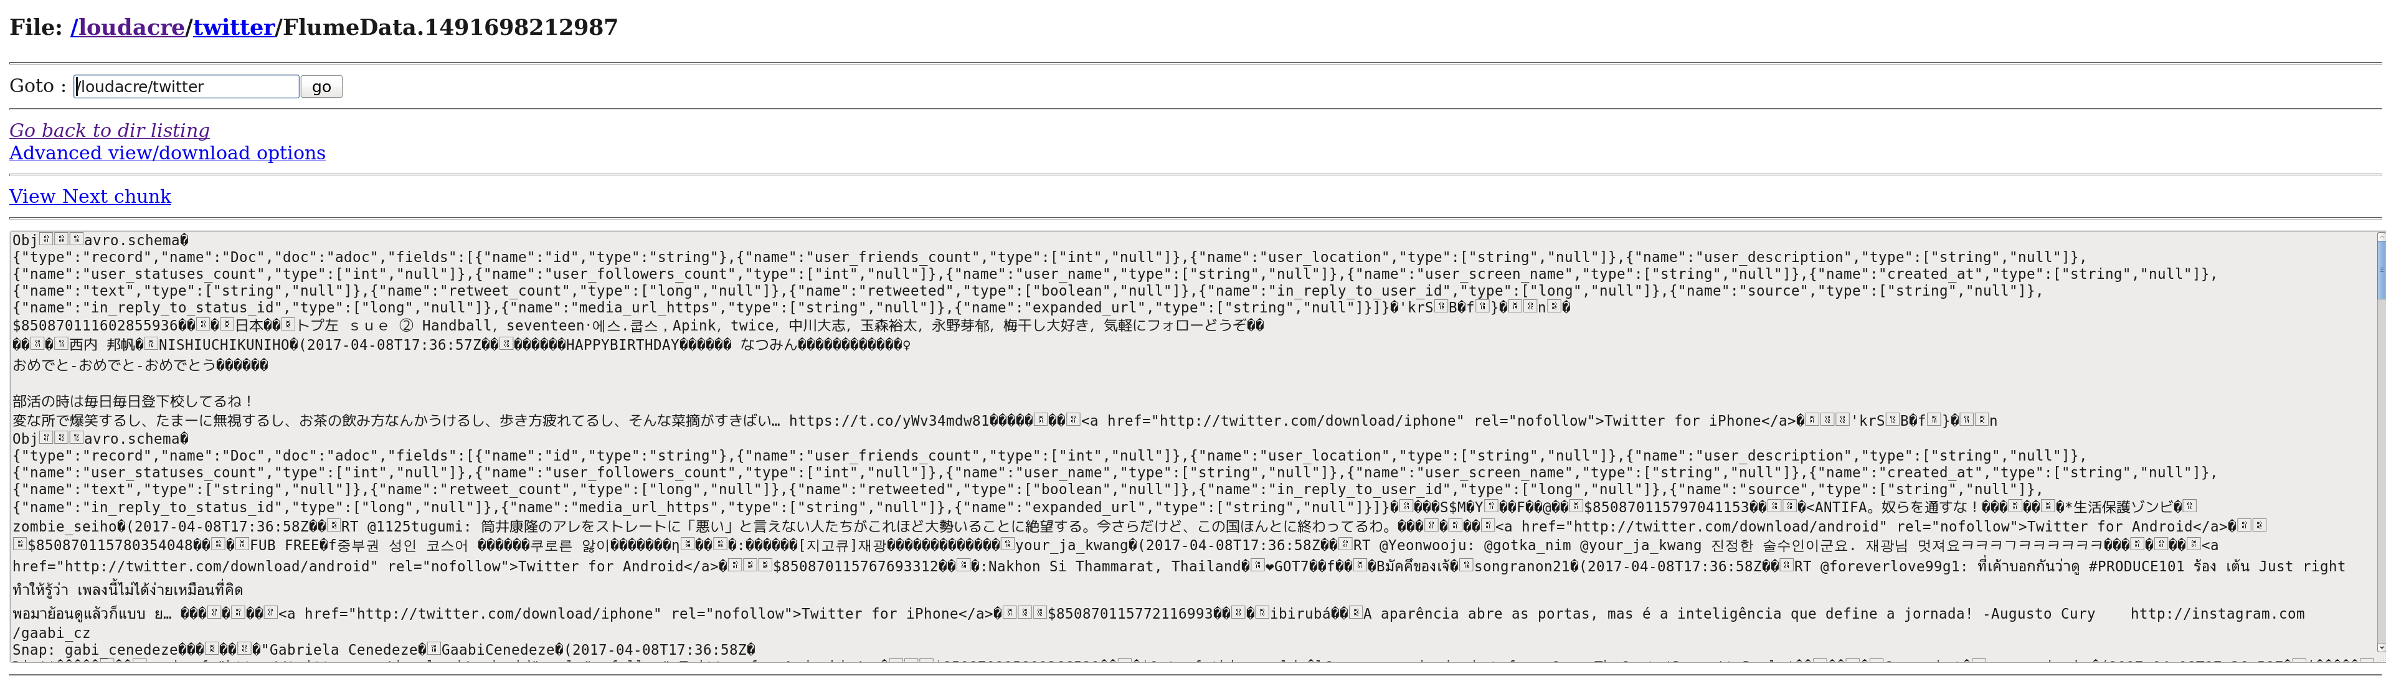

1. **Solr Configuration:**

**Follow the steps as mentioned:**

1. **Ensure following jar file are present in path : (/usr/lib/flume-ng/lib)**



1. **Configuring Solr:**

Go to path etc/default/ and set follosing properties as described below.

SOLR_HDFS_HOME=hdfs://localhost:8020/solr

SOLR_HDFS_CONFIG=/etc/hadoop/conf

/etc/Hadoop/conf should have core-site.xml and hdfs-site.xml. files

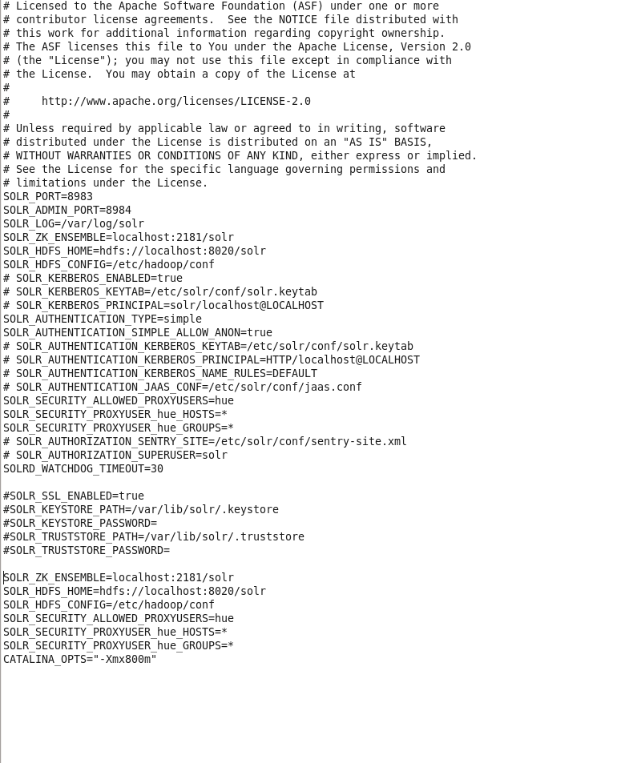

## Checking the /solr Directory in HDFS

Before starting the Cloudera Search server, you need to create the /solr directory in HDFS.

If they are not created, run following command in hdfs :

sudo -u hdfs hadoop fs -mkdir /solr

sudo -u hdfs hadoop fs -chown solr /solr

1. **Initializing the ZooKeeper Namespace**

Before starting the Cloudera Search server, you need to create the solr namespace in ZooKeeper:

$ solrctl init



## Starting Solr

$ sudo service solr-server restart

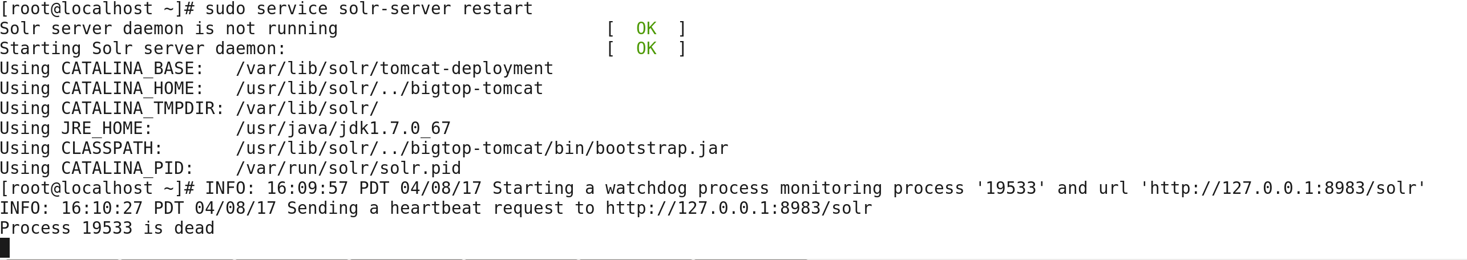

## Runtime Solr Configuration

To start using Solr for indexing the data, you must configure a collection holding the index. A configuration for a collection requires a solrconfig.xml file, a schema.xml and any helper files referenced from the xml files. The solrconfig.xml file contains all of the Solr settings for a given collection, and the schema.xml file specifies the schema that Solr uses when indexing documents.

Configuration files for a collection are managed as part of the instance directory. To generate a skeleton of the instance directory, run the following command:

$ solrctl instancedir --generate $HOME/solr_configs

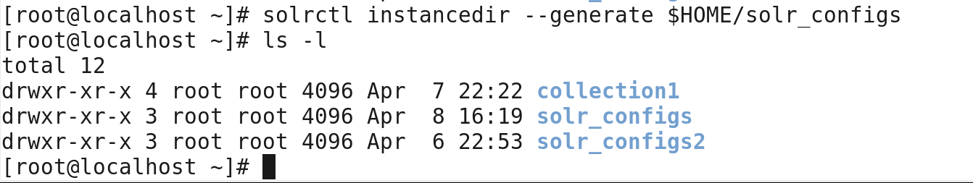

Generate the configuration files for the collection, including the tweet specific schema.xml:

cp /usr/share/doc/search*/examples/solr-nrt/collection1/conf/schema.xml \

$HOME/solr_configs/conf



After configuration is complete, you can make it available to Solr by issuing the following command, which uploads the content of the entire instance directory to ZooKeeper:

solrctl instancedir --create collection1 $HOME/solr_configs



Create the new collection:

$ solrctl collection --create collection1 -s 1 -c collection1



Verify the collection is live. For example, for the localhost, use <http://localhost:8983/solr/#/~cloud>

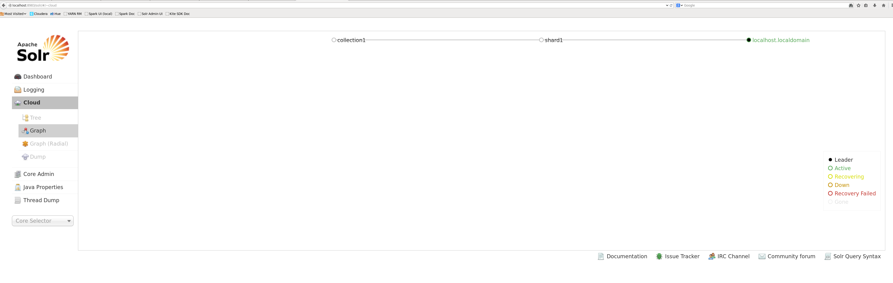

Keep solr server up and running.

1. **Flume agent configuration :**

Make sure following file are in path and properly configured.

**Morphline.conf (/etc/flume-ng/conf)**

Run following command :

cp /usr/share/doc/search-1.0.0+cdh5.4.3+0/quickstart/morphline.conf /etc/flume-ng/conf



**solr-twitter.conf (Desktop)**



# spooldir.conf: A Spooling Directory Source

# Name the components on this agent

TwitterAgent.sources = Twitter

TwitterAgent.channels = MemChannel

TwitterAgent.sinks = solrSink

# Describing/Configuring the source

TwitterAgent.sources.Twitter.type = org.apache.flume.source.twitter.TwitterSource

TwitterAgent.sources.Twitter.consumerKey=

TwitterAgent.sources.Twitter.consumerSecret=

TwitterAgent.sources.Twitter.accessToken=

TwitterAgent.sources.Twitter.accessTokenSecret=

TwitterAgent.sources.Twitter.keywords=hadoop, bigdata, mapreduce, mahout, hbase, nosql, election,sports, cricket

TwitterAgent.sources.Twitter.channels=MemChannel

# Describing/Configuring the sink

TwitterAgent.sinks.solrSink.type = org.apache.flume.sink.solr.morphline.MorphlineSolrSink

TwitterAgent.sinks.solrSink.channel = MemChannel

#TwitterAgent.sinks.solrSink.batchSize = 1000

#TwitterAgent.sinks.solrSink.batchDurationMillis = 1000

TwitterAgent.sinks.solrSink.morphlineFile = /etc/flume-ng/conf/morphline.conf

TwitterAgent.sinks.solrSink.morphlineId = morphline1

TwitterAgent.channels.MemChannel.type=memory

TwitterAgent.channels.MemChannel.capacity=1000

TwitterAgent.channels.MemChannel.transactionCapacity=1000

**Flume-env.sh (/etc/flume-ng/conf)**

Add following line into file :

export JAVA_OPTS="-Xms100m -Xmx2000m -Dcom.sun.management.jmxremote"



1. **Starting flume** **agent**

flume-ng agent --conf /etc/flume-ng/conf \

--conf-file Desktop/solr-twitter.conf \

--name TwitterAgent -Dflume.root.logger=INFO,console

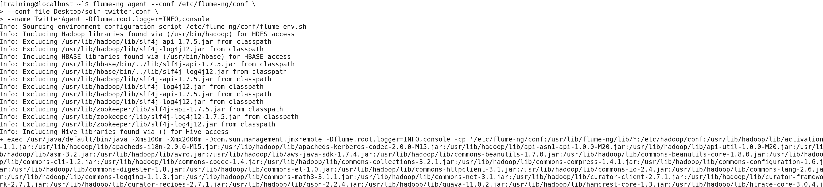

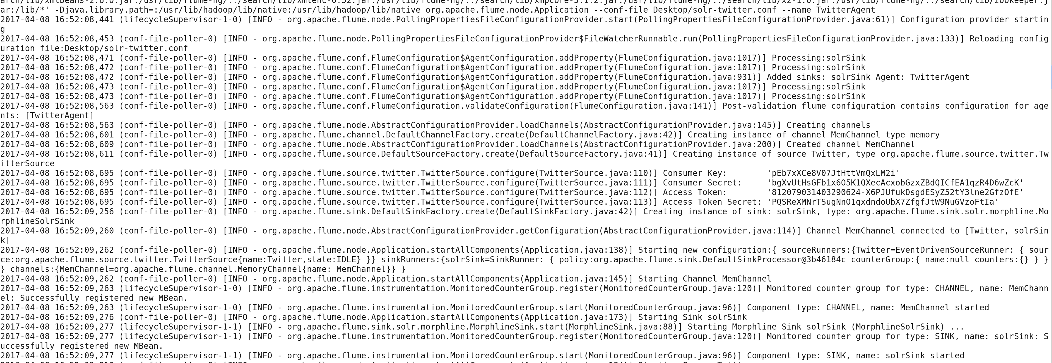

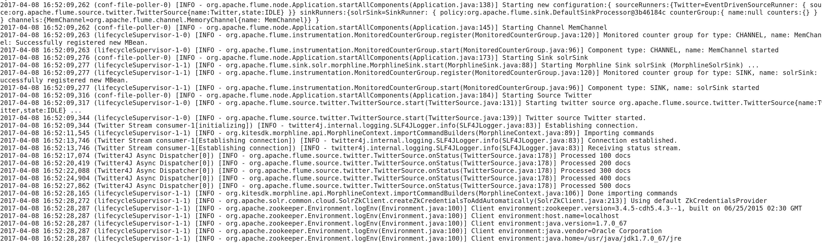

1. Following the files which are created on HDFS /solr path :

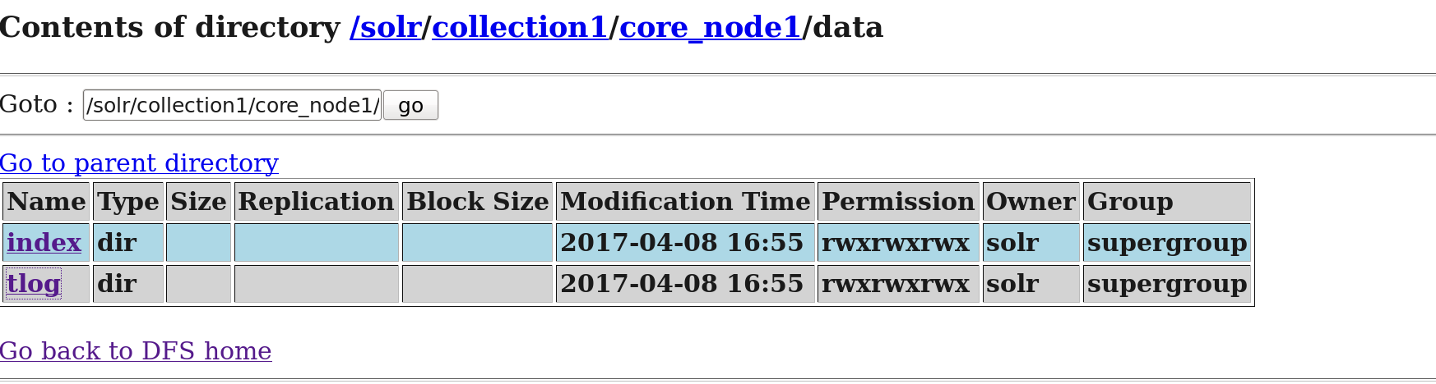

Index :

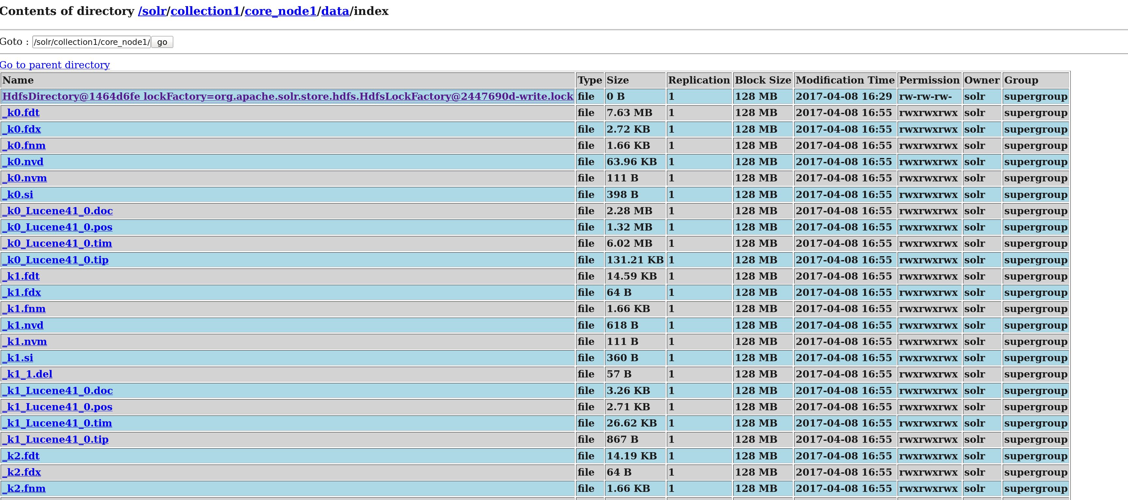

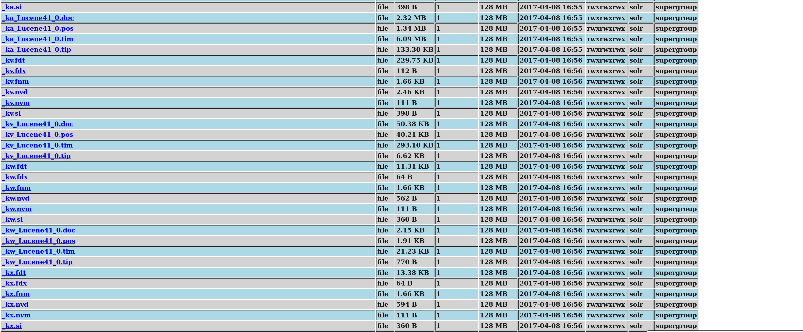

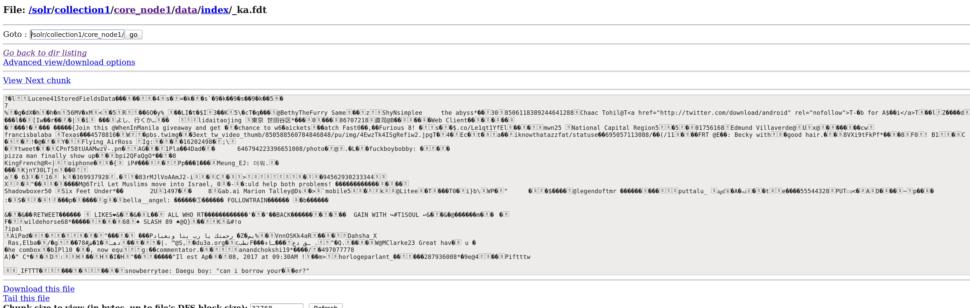

Data:

